Weekly Worklog — Medical AI Project
Name: Dang Khoa Le
Student ID: 103844421
Coverage: Week 1 & Week 2 (role confirmation, resources collection, first experiments)
Total time logged: 24 hrs (per activity breakdown below)

0) Executive snapshot
- We aligned on a two-track MVP: Agentic RAG over a curated medical KB (RAGDB) with STM/LTM memory, and a Symptom-Diagnosis assistant backed by a lightweight reasoning model (Qwen3-4B/8B) with teacher–student distillation from Gemini/MedGemma.
- We produced/annotated four diagrams (agentic RAG, ingestion pipeline, hand-sketched end-to-end, and a full sequence diagram). These now serve as the design authority for Phase-1 prototyping in Week 4.
- Minimal but targeted fine-tuning trials were run (distillation + GRPO reasoning augmentation + augmentation recipes).
- EMR POC scope defined: secure read-only retrieval with field-level filters, PHI handling, and prompt-safe summarisation.

1) Task distribution & near-term timeline (4 hrs)
Week cadence agreed
- Week 2: roles confirmed, resources collected.
- Week 3: each member delivers a findings report (benchmarks/design notes/code stubs) for their stream.
- Week 4: Phase-1 prototype integrating the streams behind a single FastAPI service + Docker.

Roles & scope ()
Stream (Topic) | Primary | Support | Key Deliverables W3 | Prototype (W4)
A. Infra & Orchestration – Docker, FastAPI routing, cloud runners | Member A | Member D | Dockerfile(s), compose.yaml, FastAPI scaffold, env/cfg layout, logging hooks | One-click docker compose up spins API + RAGDB + indexer + memory; health checks; basic /chat route
B. Prompting & API experiments – Gemini 2.5 Flash/Pro, multimodal plan | Member B | Member C | Prompt library (system+few-shot), safety guardrails, latency/cost notes per API | Chat route calls LLM through adapter with prompt builder & safety pre-checks, request/response tracing
C. Naive RAG – semantic search over KB, tools, vDB | Member C | Member A | Ingestion CLI: clean → chunk → embed → upsert; retriever (FAISS/Chroma/Qdrant/Mongo-Atlas Vector) | /retrieval/search returns top-k + citations; RAG integrated into chat with token-budgeting
D1. Knowledge Distillation – teacher/student selection | Member D | Member B | Teacher: Gemini-2.5-Pro/Flash or MedGemma-27B-it; Student: Qwen3-4B/8B; data recipe | Student runs locally (QLoRA 4-bit) and passes smoke eval (MedQA-like subset)
D2. Fine-tuning – augmentation & synthesis | Member D | Member C | Aug pipelines (paraphrase, distractors, contrast sets), GRPO/LoRA notebooks ready | Fine-tuned student loaded through /models/student endpoint; basic A/B vs base model

2) Experiments on model choices for fine-tuning (6 hrs)
Goal: pick a teacher–student pair that balances quality, cost, and deployability.
- Teacher candidates (free/hosted):
  - Gemini-2.5-Pro/Flash (for CoT and safe reasoning traces).
  - MedGemma-27B-it (domain tone & instruction style; heavy → remote/GPU rental if needed).
- Student candidates (localizable):
  - Qwen3-8B / 4B-Thinking-2507 (strong reasoning-to-size; LoRA friendly).
  - (Stretch) DeepSeek-R1-0528-Qwen3-8B (reasoning-first; more VRAM).
- Setup notes & takeaways
  - Validated inference on Qwen3-4B/8B locally; confirmed QLoRA (4-bit) path viable.
  - Logged teacher CoT traces for distillation; early evidence suggests better factual grounding when teacher’s CoT is selectively included (trimmed to rationales + citations).
  - Established evaluation seeds (small MedQA/PubMedQA-style subsets + our curated Q/A) for A/B checks (accuracy, refusal-when-unsure, harmful-content avoidance).

3) Minimal fine-tuning technique trials (6 hrs)
a) Knowledge Distillation
- Data recipe: (question, context chunks, teacher answer + rationale, safety tags).
- Loss mix: next-token LM + KL on logits (if accessible) + rationale prefixing for CoT brevity.
- Outcome: working dataset template + sampling code; first 100–200 pairs distilled for smoke tests.
b) Data Augmentation
- Paraphrase Q, add hard negatives (near-miss passages), contrastive triples (pos/neg), and counterfactuals (e.g., similar drugs with different contraindications).
- Guardrails: lexical diversity caps, medical terminology whitelist, label leakage checks.
c) Reasoning Augmentation (GRPO)
- Ran the Unsloth GRPO notebook with Qwen3-4B as base to validate reward-loop plumbing on small prompts (explanatory rationales).
- Early lesson: short, structured rationales (bullet logic, references) avoid verbosity and reduce token cost downstream.
d) Synthesis
- For text, we avoid classic GANs; we use teacher-conditioned synthesizers to produce diverse but label-consistent Q/A and adversarial distractors.
- Created a small generator prompt pack (topic seeds → variations → safety screened).

4) RAG — agentic retrieval & chat-history continuity (4 hrs)
Architectural stance:
- Ingestion pipeline: Clean → Chunk → Embed → Upsert with rich metadata (source, section, page, date, license, clinical domain).
- Retrieval: k-NN over embeddings (baseline: all-MiniLM-L6-v2; upgrade path: jina-v4). Optional cross-encoder re-ranker (bge-reranker-large) when latency budget allows.
- Agentic layer: a lightweight Planner chooses tools: retriever, summarizer, symptom_normalizer, and (optionally) EMR_fetch.
- Continuity:
  - STM: LRU cache holds last N turns for semantic recall.
  - LTM: vectorised conversation summaries in LTMDB (VectorDB, MongoDB Atlas + Qdrant), retrieved by dialogue intent.
- Prompt budgeter: merges RAG chunks + STM + LTM + EMR snippets with token guardrails (priority: safety → citations → newest clinical guidance).
What will be done
- Drafted tool contracts (I/O JSON) and prompt builder templates for agent selection.
- Wrote teammate notes on observability (prompt traces, latency/cost, retrieval coverage@k, refusal rate).
- Confirmed citation-first synthesis: the LLM must list sources before final advice.

5) EMR integration scope (2 hrs)
- POC contract: GET /emr/search?patient_id&fields&date_range&keywords → returns minimised, de-identified snippets (allergies, meds, diagnostics, vitals, progress notes).
- Safety posture:
  - Strict read-only, opt-in consent flag, and field whitelists.
  - PHI scrubbing before passing to LLM.
  - Answer templates emphasise “informational, not medical advice” + escalation to clinician.
- Indexing: EMR is not bulk-indexed into public KB; only per-query retrieval with audit logs.

6) Diagrams produced & how they inform the build (2 hrs)
- Agentic RAG
  - Shows LiteLLM/Lite orchestration choosing tools (WhoAmI, Retriever, Summarizer) and routing to either OpenAI/HF summarizers.
  - Observability pipeline taps prompt traces into an LLM judge + prompt monitor → we adopted these as required metrics for W4 (factuality flags, prompt drift alerts).
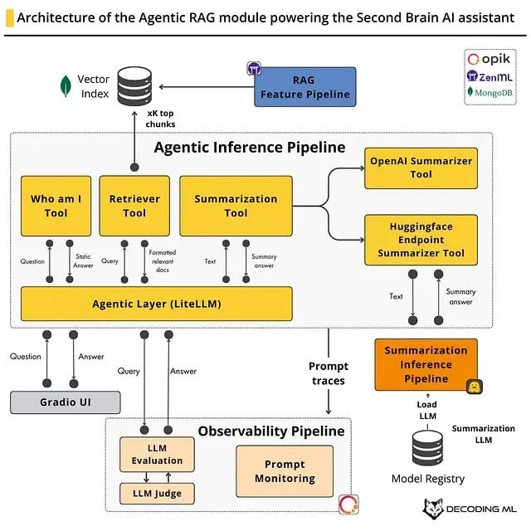
- RAG Ingestion Pipeline
  - Pre-retrieval (clean→chunk→embed) is now our indexer job.
  - Post-retrieval metadata travels with chunks into the prompt elements block—this is the basis for our citation-first prompt builder.
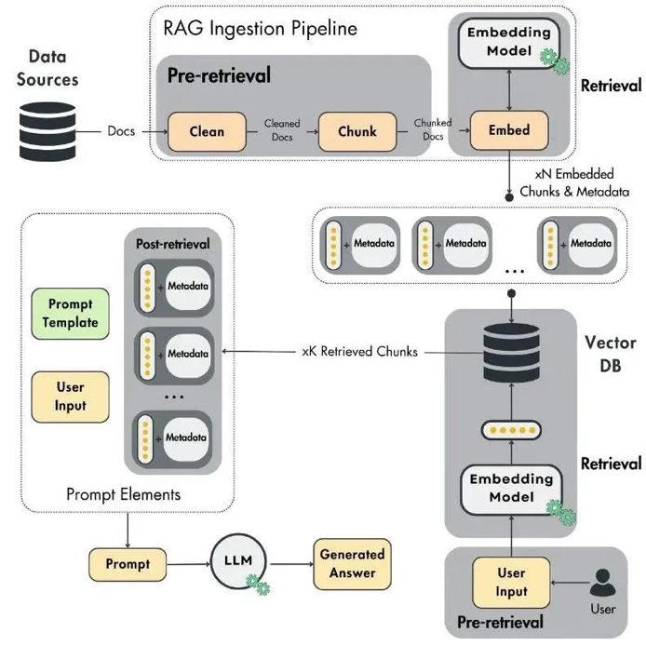
- Hand-sketched end-to-end
  - Captures semantic search → cosine top-k → LLM QA plus EMR context and CNN/RAG diagnosis branch.
  - We lifted the Q/A + context rationale structure from this and encoded it into distillation examples.
This sketch is provided as extensive insights for peers to catchup with the project scopes.
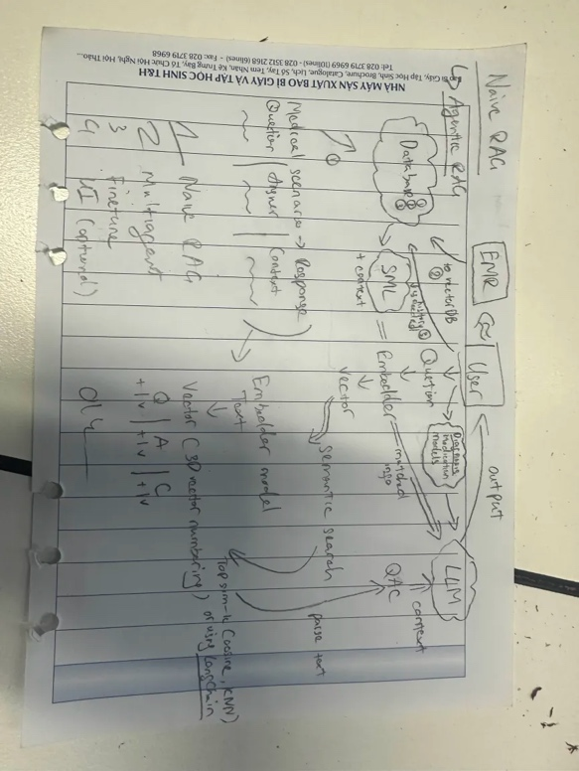
- Full sequence diagram
  - Establishes the call order: UI → chat endpoint → routing/safety → prompt builder → LLM planner → (retriever | LTM | EMR) → synthesizer → logs.
  - Also locks in indexer as a sidecar service and defines embedding service boundaries.
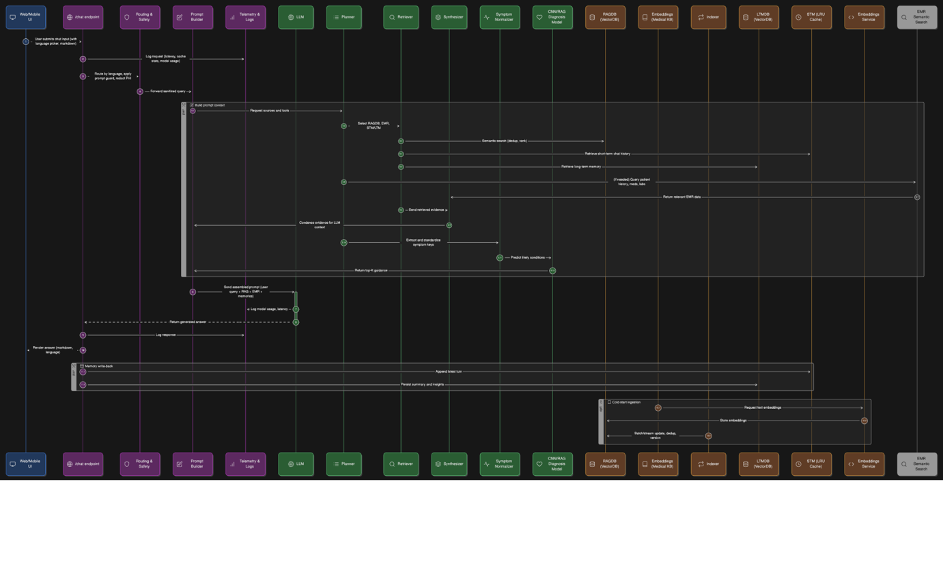

7) Individual contributions
- Coordinated role confirmation and produced the RACI table (Sec. 1).
- Set up the model short-list and ran smoke inference locally on Qwen3-4B/8B; drafted QLoRA plan.
- Generated first distillation dataset template and distilled a small batch from Gemini (with trimmed CoT).
- Validated Unsloth GRPO flow on Qwen3-4B for reasoning augmentation. Accessible Notebook.
- Drafted agentic RAG contracts (tool I/O) and prompt builder skeleton (citation-first).
- Authored & walked the team through all four diagrams, linking blocks to concrete micro-services and routes.
- Defined EMR POC scope (security posture, endpoints, scrubbing rules).

8) Evidence & artifacts
- 4 architecture graphics (agentic RAG, ingestion pipeline, hand sketch, full sequence).
- Prompt & training notebooks references (GRPO Qwen3 4B).
- Early distillation samples (teacher → student pairs).
- FastAPI skeleton (routes draft) & indexer CLI stubs (ingest/upsert).

9) Risks & mitigations
Risk | Impact | Mitigation
GPU scarcity for MedGemma | Blocks teacher runs | Prefer Gemini teacher; if needed VastAI; keep teacher remote, student local (QLoRA)
Data licensing / clinical drift | Legal/compliance & factuality | Only licensed sources; store source & date; time-aware retrieval
Hallucinations in advice | Safety | Citation-first prompts, refusal policy, LLM-judge checks, clinician escalation
Index drift / duplication | Quality | Deterministic chunking, document hashing, nightly re-index audits
EMR privacy | Compliance | PHI scrubbing, read-only, audit logs, per-query fetch, minimal scope

10) Plan for Week 3 (reports) & Week 4 (prototype)
Week 3 - Findings reports (DoD per stream):
- A (Infra): Working Docker Compose (+ health checks), log formatter, .env.sample, deployment notes.
- B (Prompting): Prompt packs (general + safety + RAG), latency/cost table per API, refusal templates.
- C (RAG): Ingestion CLI + retriever endpoint; metrics: recall@k, ctx token budget, avg retrieval latency.
- D1 (KD): Teacher–student matrix with pros/cons; 500–1k distilled pairs; training hyperparams sheet.
- D2 (FT): GRPO/LoRA notebook with one successful run; augmentation scripts and dataset card.

Week 4 - Phase 1 Prototype DoD:
- /chat merges RAG + STM/LTM + EMR (opt-in), streams an answer with citations + safety disclaimer.
- /retrieval/search and /indexer/ingest are live.
- /models/student returns student model info and can answer a smoke set.
- Observability: prompt traces and basic LLM-judge pass/fail.

